# NETWORK INTRUSION DETECTION USING

# MACHINE LEARNING ALGORITHMS

# A PROJECT REPORT

*for*

# INFORMATION SECURITY ANALYSIS AND AUDIT

# (CSE3501)

*in*

# B. Tech (Information Technology)

*By*

# KSHITIJ DHYANI

# (18BIT0131)

# JAHNAVI MISHRA

# (18BIT0243)

# Fall semester, 2020

*Under the Guidance of*

# Prof. SUMAIYA THASEEN I

Associate Professor Grade 1, SITE



# School of Information Technology and Engineering

YOUTUBE VIDEO

<https://www.youtube.com/watch?v=aDmXbgoX_K4>

GITHUB

<https://github.com/wimpywarlord/darknet2020ML>

* **Performance Analysis:**
* **Prediction of Label 1 :**
* **After Hyperparameter Tuning:**

|  |  |  |
| --- | --- | --- |
| Evaluation Metric | Gradient Boosting Classifier | AdaBoost Classifier |
| ACCURACY | **1.00** | **0.944** |
| PRECISION | **1.00** | **0.999** |
| RECALL | **1.00** | **0.969** |
| F-SCORE | **1.00** | **0.984** |
| SUPPORT | **Class 0: 7203**  **Class 1: 7097**  **Class 2: 7040**  **Class 3: 6728** | **Class 0: 7116**  **Class 1: 7210**  **Class 2: 6834**  **Class 3: 6908** |

* **Confusion Matrix**

**GBM:**

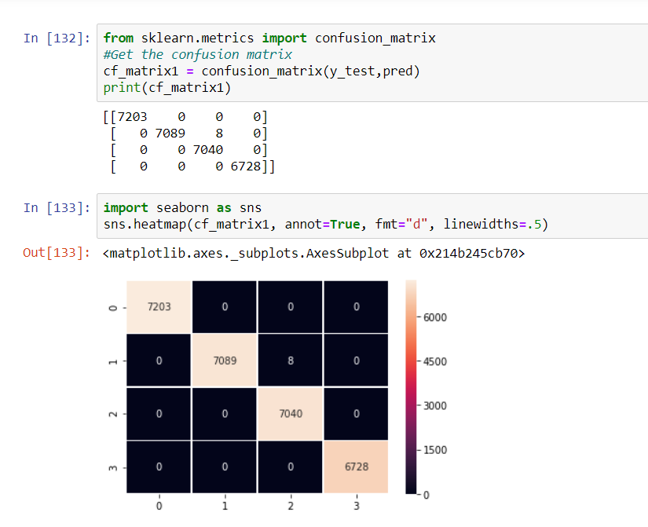

**For AdaBoost:**

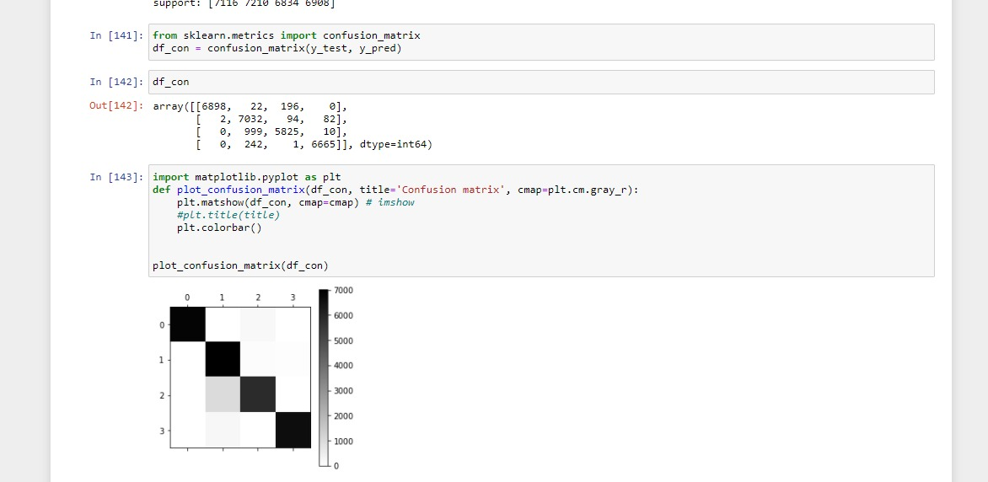

* **Results and Conclusion:**

***As seen above, GBM gives better results for prediction of Label 1 in Darknet 2020 as compared to AdaBoost.***

* **Binary Classification on Label 1:**
* **After Hyper Parameter Tuning:**

|  |  |  |
| --- | --- | --- |
| Evaluation Metric | Gradient Boosting Classifier | AdaBoost Classifier |
| ACCURACY | **1.00** | **1.00** |
| PRECISION | **1.00** | **1.00** |
| RECALL | **1.00** | **1.00** |
| F-SCORE | **1.00** | **1.00** |
| SUPPORT | **Class 0: 7133**  **Class 3: 6898** | **Class 0: 7094**  **Class 3: 6935** |
| AUC_ROC SCORE | **1.00** | **1.00** |

* **Confusion Matrix**

**For GBM:**

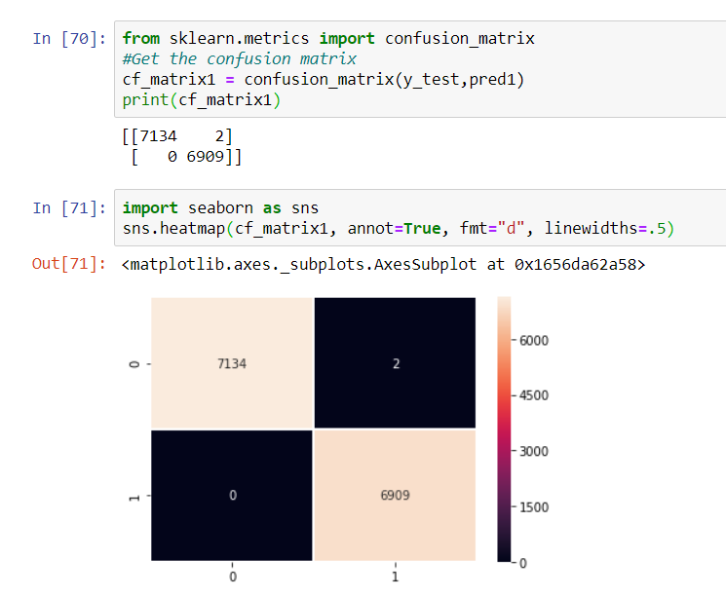

**For AdaBoost:**

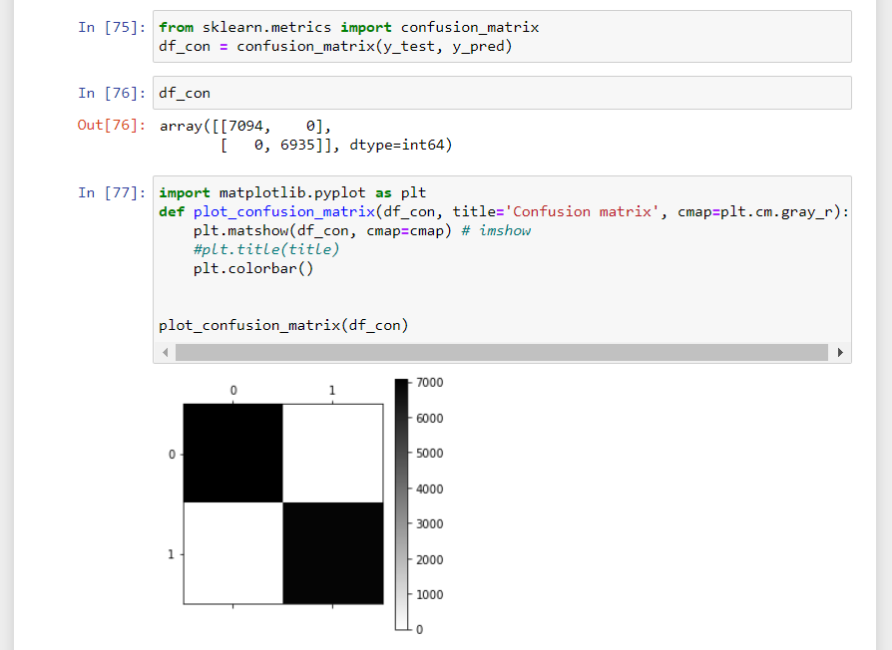

* **AUC_ROC Curve:**

**For GBM:**

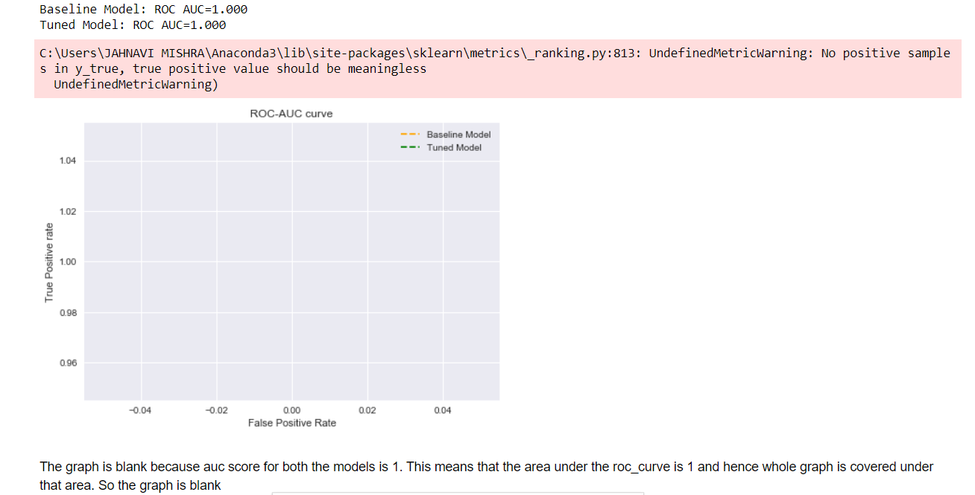

**For AdaBoost:**

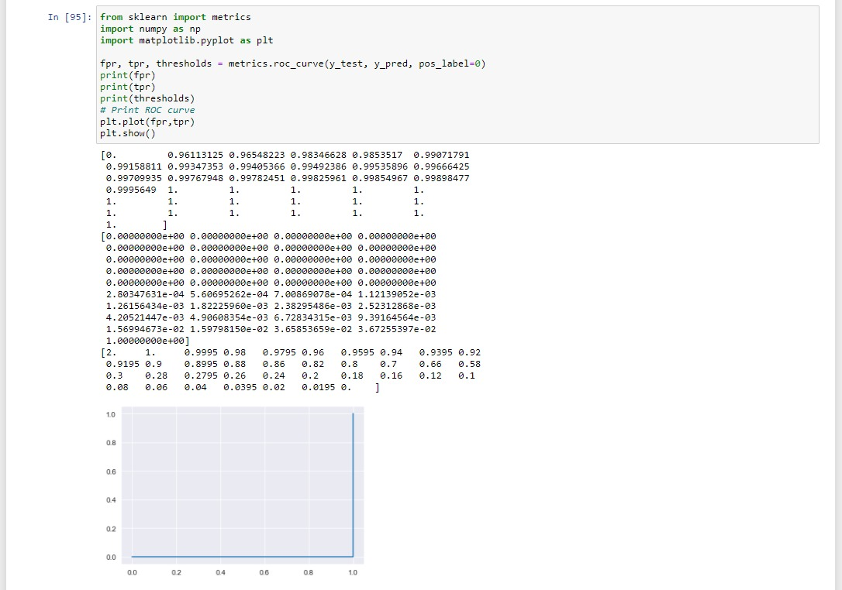

The graph is blank because auc score for both the models is 1.

This means that the area under the roc_curve is 1 and hence whole graph is covered under that area.

So the graph is blank.

* **Results and Conclusion:**

***As seen above, both GBM and AdaBoost give similar results for binary classification of Label 1 in Darknet 2020 and are equally and highly efficient.***

**However GBM Still has a little bit of an upper edge.**

* **Prediction of Label 2:**

The accuracy obtained by GBM before tuning was around 0.65-0.75 but by AdaBoost it came out to be around 0.18-0.21 only.

After tuning, the best accuracy GBM obtained was 0.87.

So GBM is better for this prediction and AdaBoost is not at all fit for this prediction. Results depend upon the target label and dataset as well. So same models may work differently for different labels of a same dataset.

**GBM:**

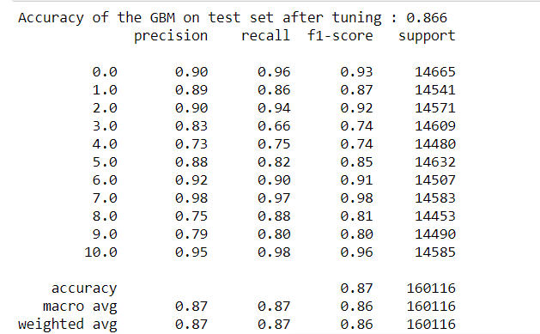

**AdaBoost :**

Kshitij Tired using his algorithm of adaboost and achieved a accuracy of just 2

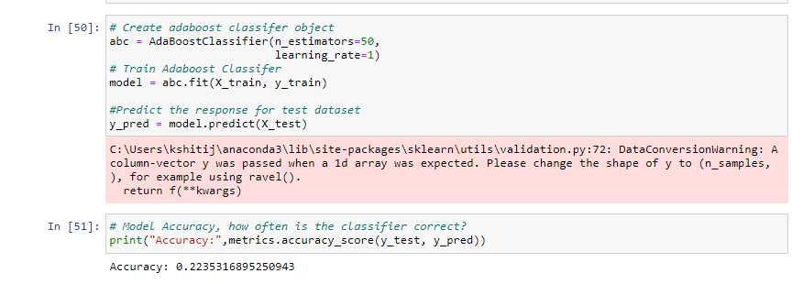

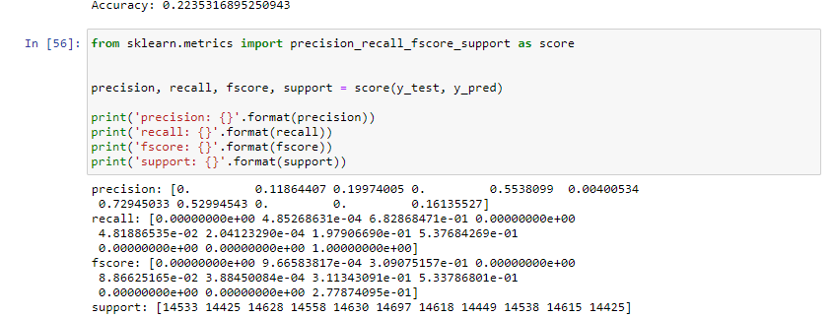

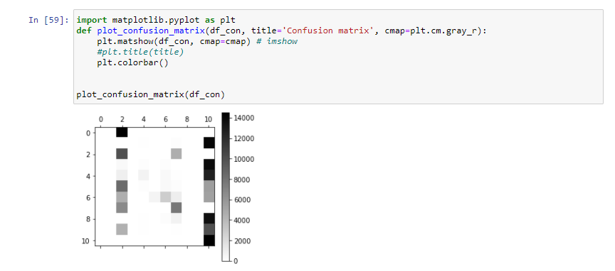

* **Code And Output:**
* **Importing Dataset:**

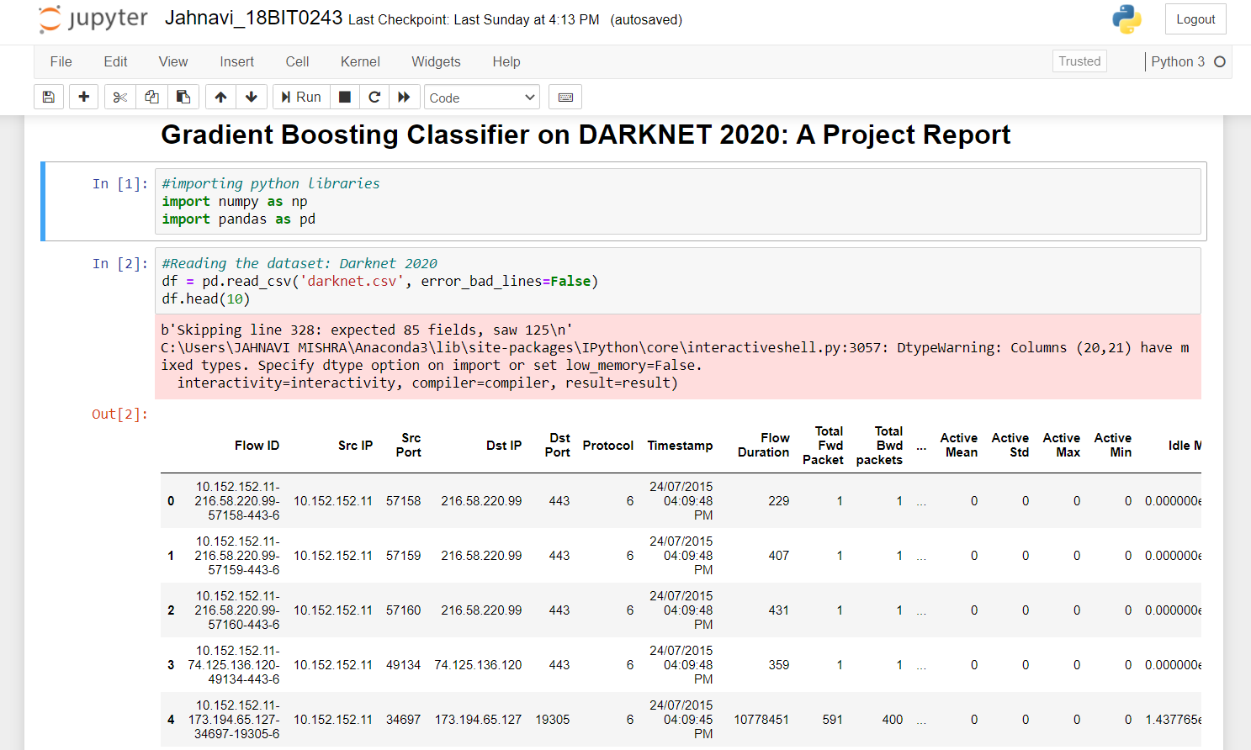

* **Data Cleaning:**

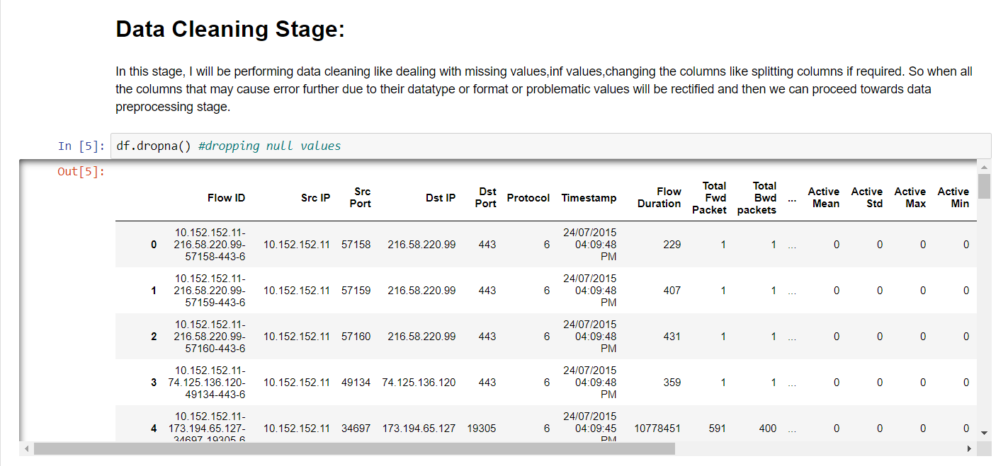

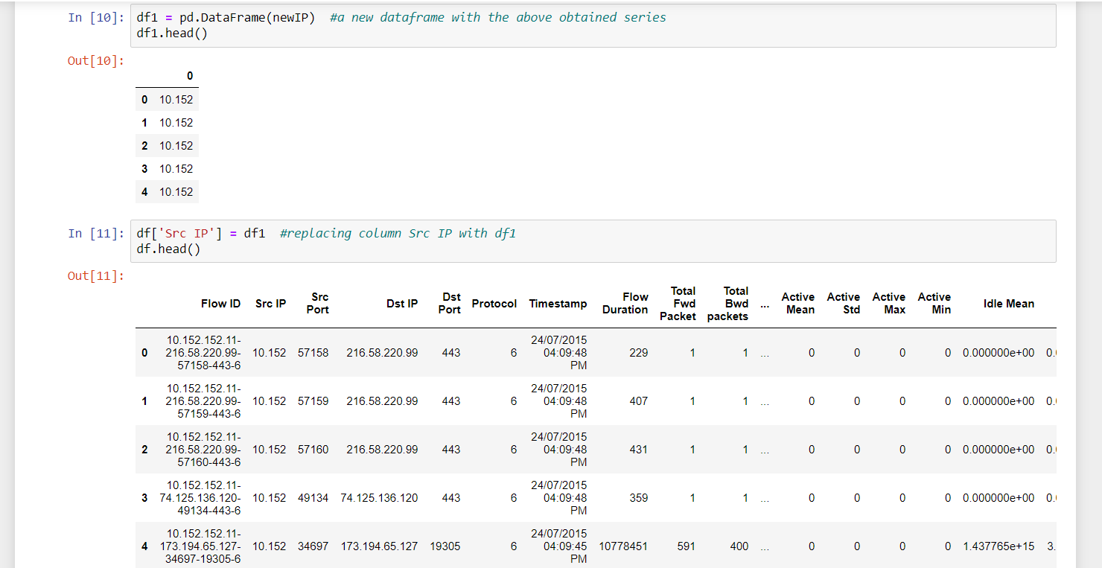

* **Data Pre-Processing:**

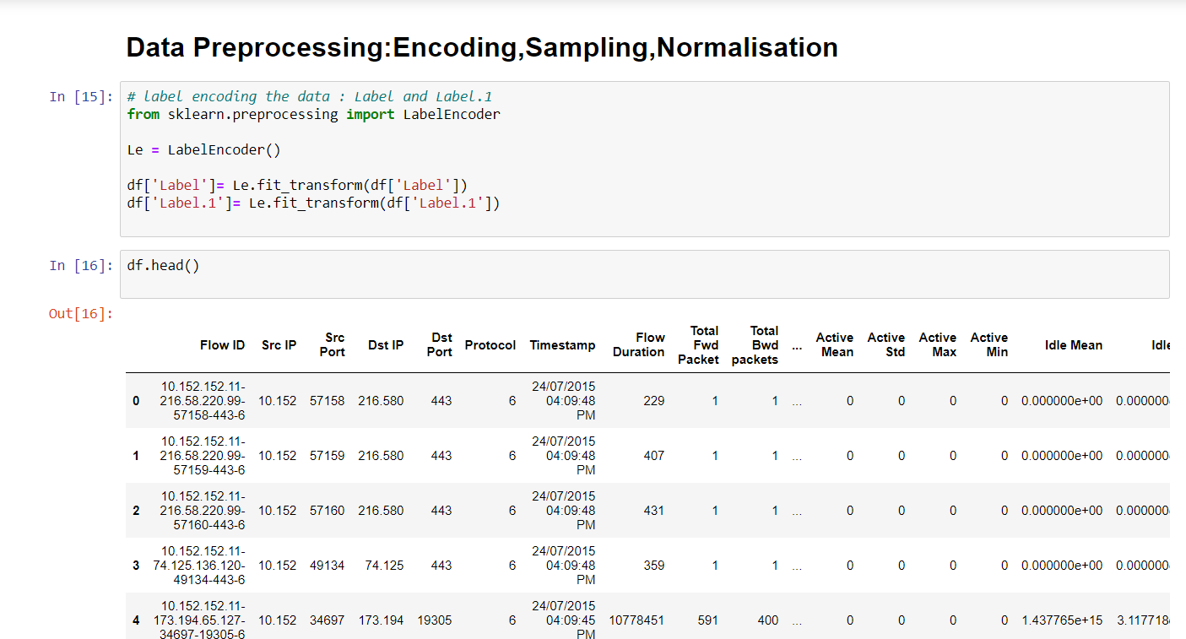

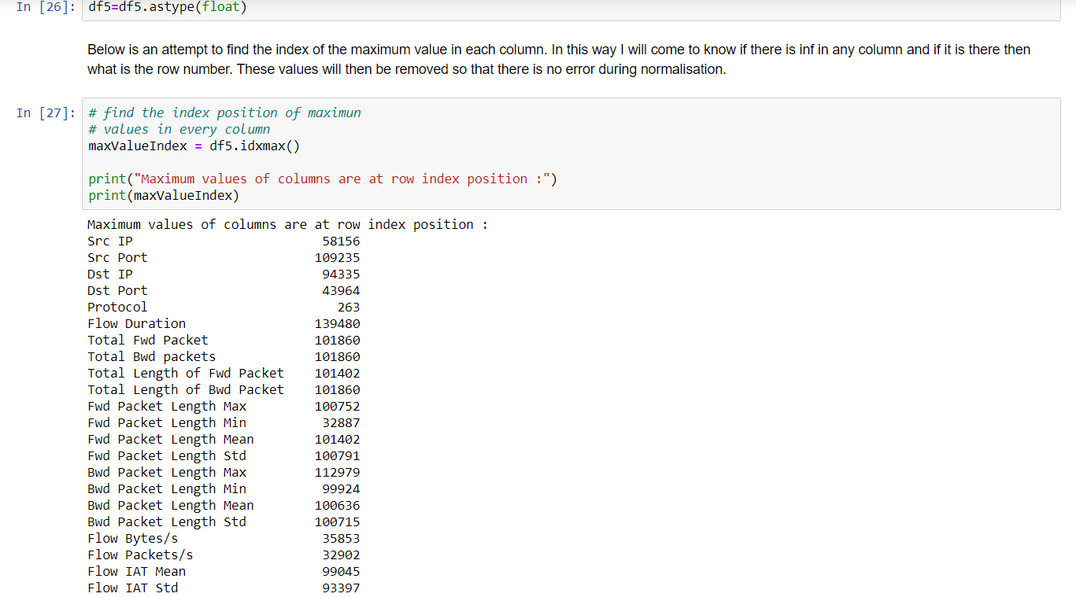

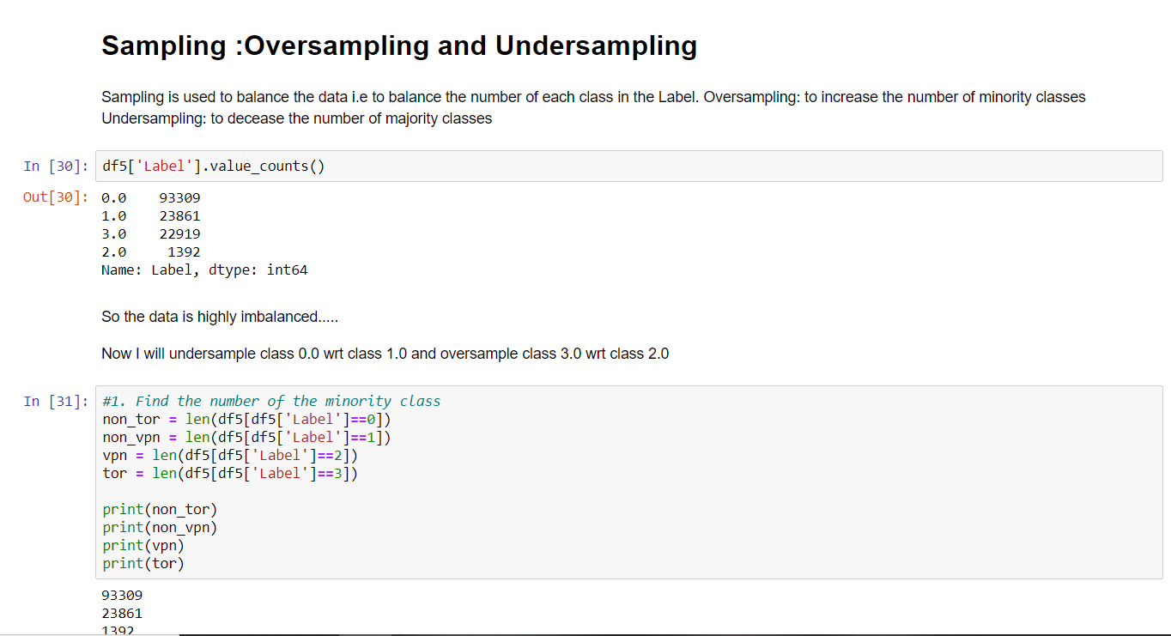

* **Feature Extraction:**

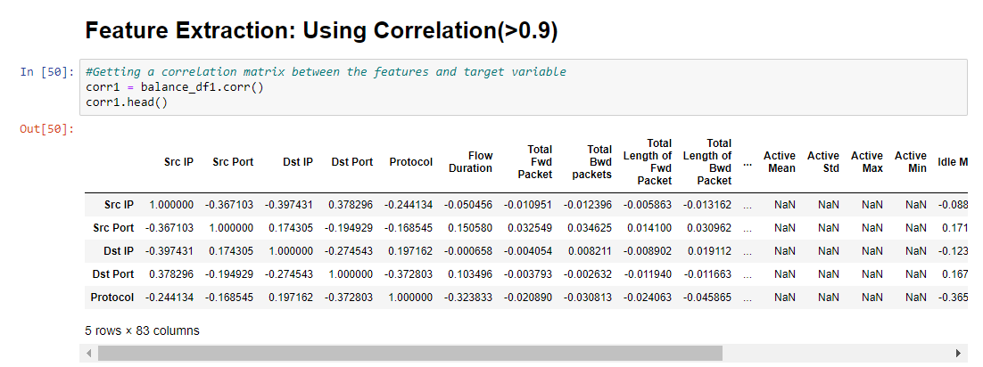

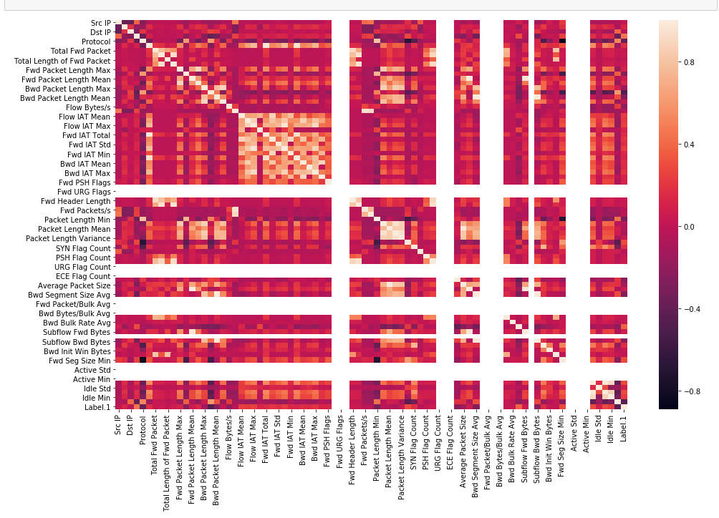

* **Model Training and Testing Phase:**

